1. 8-QUEEN PROBLEM
Aim
To write a Python program to solve the 8-Queen problem using Backtracking.
Objective
To place 8 queens on an 8×8 chessboard so that no two queens attack each other.
Algorithm
• To understand the Backtracking algorithm.
• To place eight queens on an 8×8 chessboard so that no two queens attack each other.
• To display one valid solution.
Algorithm
• Start.
• Read the size of the chessboard (N) from the user.
• Place a queen in the first column.
• Check whether the position is safe.
• If safe, place the queen and move to the next column.
• If no safe position is found, backtrack to the previous column.
• Repeat until all queens are placed.
• Display the chessboard.
• Stop.

FLOWCHART

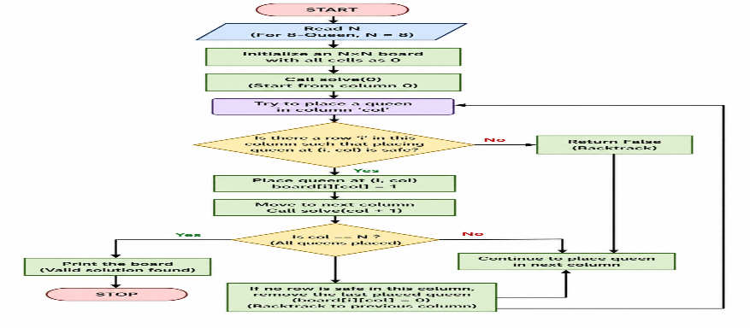

Python code:
def is_safe(board, row, col, n):

for i in range(row):
if board[i] == col:
return False

i = row - 1
j = col - 1
while i >= 0 and j >= 0:
if board[i] == j:
return False
i -= 1
j -= 1

i = row - 1
j = col + 1
while i >= 0 and j < n:
if board[i] == j:
return False
i -= 1
j += 1

return True

def solve(board, row, n):

if row == n:
return True

for col in range(n):
if is_safe(board, row, col, n):
board[row] = col

if solve(board, row + 1, n):
return True

board[row] = -1

return False

def print_board(board, n):

print("\nSolution:\n")

for i in range(n):
for j in range(n):
if board[i] == j:
print("Q", end=" ")
else:
print(".", end=" ")
print()

n = int(input("Enter the value of N: "))

board = [-1] * n

if solve(board, 0, n):
print_board(board, n)
else:
print("No Solution Exists")

Output
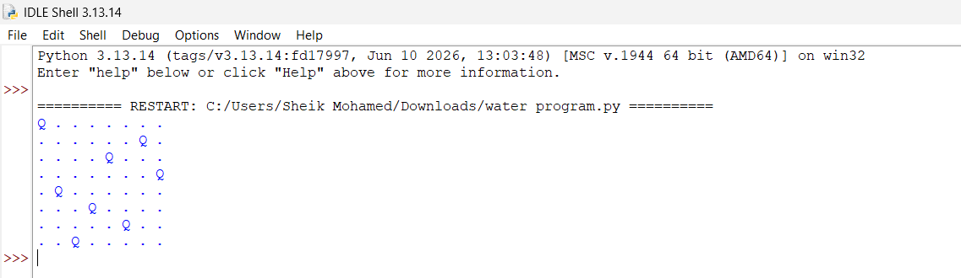
Result
Thus, the Python program to solve the 8-Queen problem was executed successfully.
Conclusion
The 8-Queen problem successfully solved

